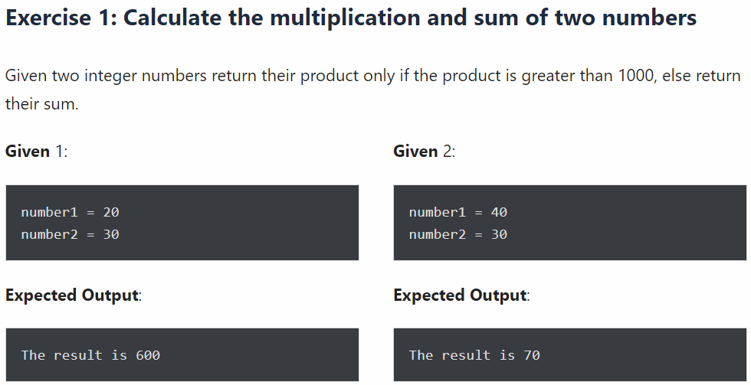

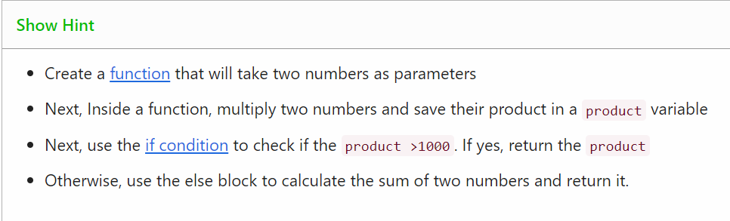

def multiplication_or_sum(num1,num2):

#calculate product of two number

Product=num1*num2

#check if product is less than 1000

If product<=1000:

Return product

Else:

#product is greater than 1000 calculate sum

Return num1+num2

#first condition

Result=multiplication_or_sum(20,30)

Print(“The result is”,result)

#second condition

Result=multiplication_or_sum(40,30)

Print(“The result is”,result)

**Print characters from a string that are present at an even index number**

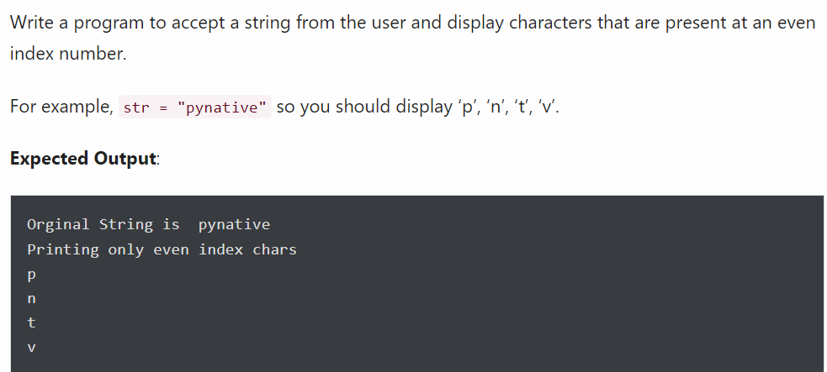

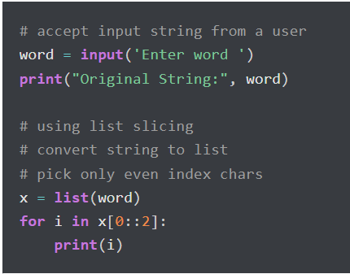

### Check if the first and last number of a list is the same

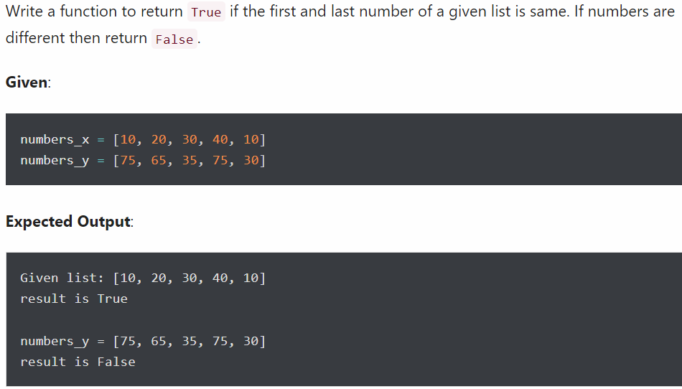

### Display numbers divisible by 5 from a list

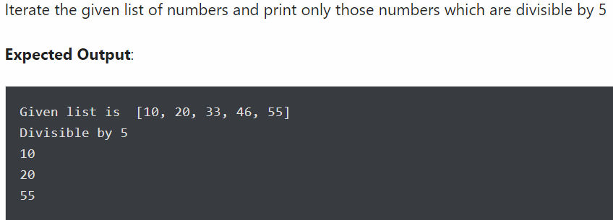

### Return the count of a given substring from a string



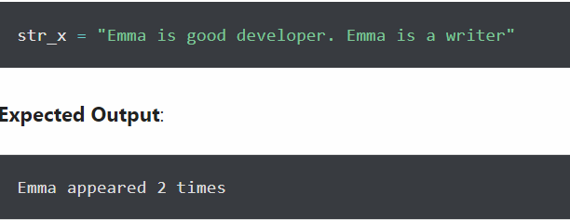

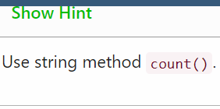



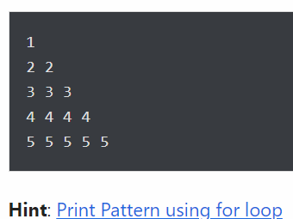

### Create a new list from a two list using the following condition

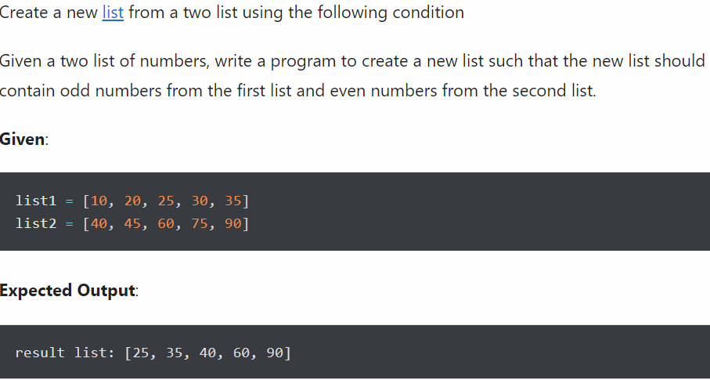

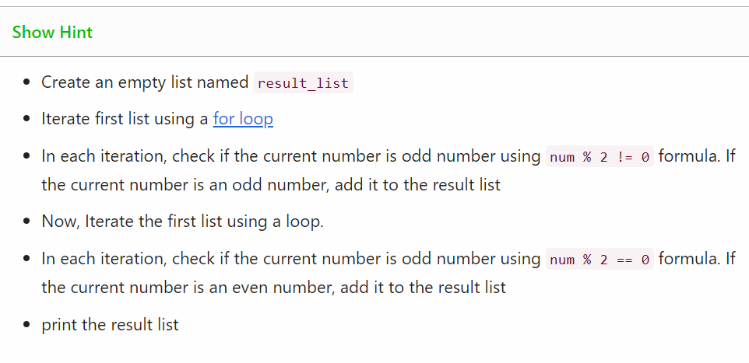

### Print multiplication table form 1 to 10

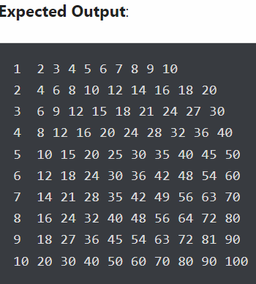

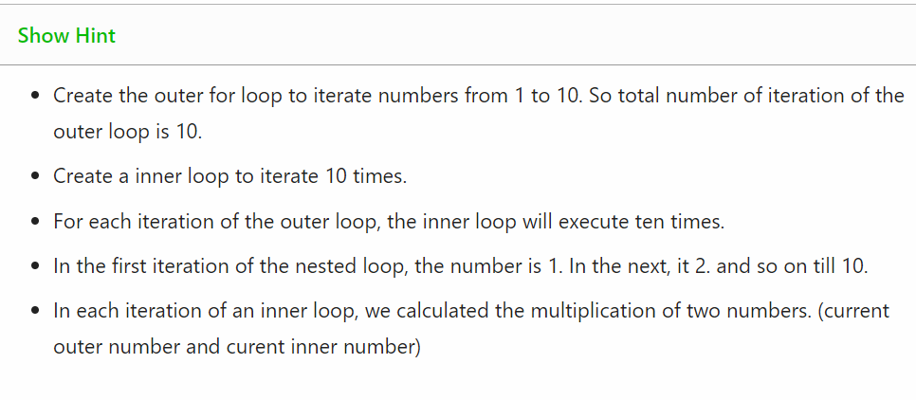

### Print downward Half-Pyramid Pattern with Star (asterisk)

